Chapter Three

Design of Proposed Technique

3.1 Introduction
Association rule mining, as has been defined in chapter two, is “finding interesting association relationships among a large set of data items”. All association rule mining algorithms, with all their variances, consist of two main phases: first finding frequent itemsets according to the given minsup value, and second, extracting rules from these frequent itemsets. As it is usual, the first phase of every association rule algorithm is time consuming and requires more processes due to multiple database scans which cause I/O bottleneck and finding subsets of every itemset is a time consuming task. All known algorithms use some sort of pruning according to the minsup at the first phase which requires re-run the program for every change in database and/or minsup value.
This chapter introduces algorithms that separates running time of the two phases, by adding an inter level consists of a database that contain frequencies of itemsets (support count). Its goal is to fetch data from multiple databases to a main server and store it in a suitable format for generating rules. The first phase can be run at dead time (after hour time for example) which accumulates new itemset frequencies on the old ones and run Rule-finder programs to extract rules at work time.
By saving itemset frequencies in mass storage hard discs (logically in databases) require new algorithms or twisting existing ones to reduce I/O time between server and its hard discs otherwise we will face a problem of delaying rule generation at the second phase. By removing pruning at the first phase and saving all itemset frequencies there are opportunities to find targeted items relation or finding weak relation between items which is impossible by existence of pruning for non-frequent.
Because of the algorithm is targeted to the multiple databases, there may be inconsistent coding for data in different databases. To overcome this problem we introduce a reference table that codes each item or gives multiple items the same code which simplifies inconsistency problem and also it helps to provide an abstraction level of items.
3.2 The Proposed System
The proposed technique is an association rule mining system that aimed to work on the multiple databases on a network. It has been proposed to be mainly consist of three parts named:
a. Data-collector
b. Frequency-base and ReferenceTable
c. Rule-finder
The Data-collector is responsible for fetching and collecting data from multiple databases on the network and substitute replace items with ReferenceTable codes and then finding power set for every item fetched and send their frequencies to a Frequency-base.
The second part of the system is a combination of Frequency-base and ReferenceTable. Frequency-base consists of tables for each k itemset. Each table contains coded itemsets and their frequencies. The ReferenceTable provides codes and meanings for each item.
The Rule-finder is mainly responsible for finding association rules according to the users’ demand of specific minimum support and minimum confidence values. Figure 3.1 shows the proposed approach architecture. The algorithms for these phases and sub-steps are detailed in the following sections.


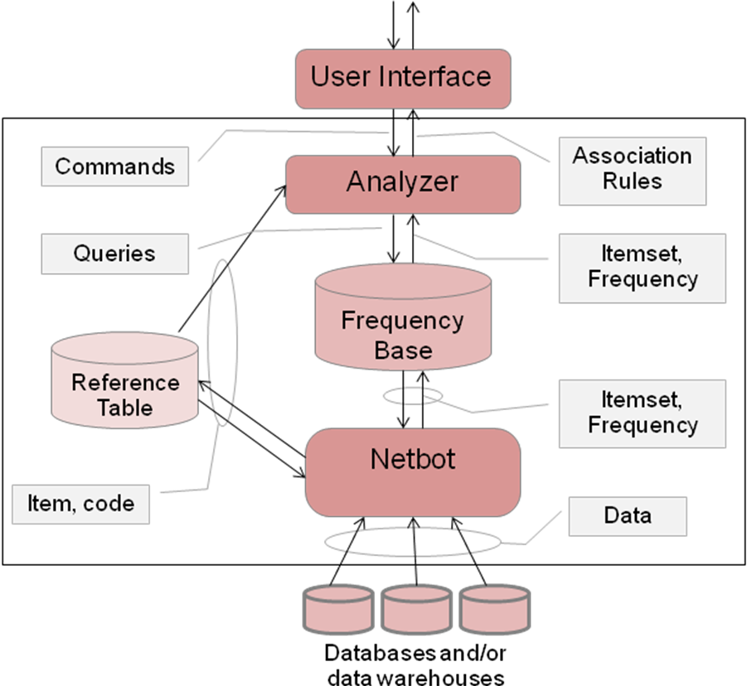
Figure 3.1The proposed technique architecture

Figure (3.1) Databot System block diagram

Rule-finder
Data-collector

Databases

3.3 Target Database
Almost all algorithms of data mining specially association rules needs some sort of preprocessing on the dataset that to be mined. The final layout is important because it represents the input to the mining algorithm and every algorithm expects specific layout. There are two possible layouts of the target dataset for association mining: horizontal and vertical layouts. Each layout has its advantage and disadvantages [MANE99, HUSS02b].
The Proposed Technique algorithms do not use preprocessing as a separate step and do not use intermediate files or databases between transactional database and finding support count process to store dataset. It simply converts each transaction immediately before using it, this is possible because Proposed Approach just scans database only once.
3.3.1 Horizontal layout
Horizontal layout is the standard format used by many researchers [OGIH98]. Here dataset consists of a list of transactions. Each transaction has a Transaction IDentifier TID followed by a list of items in that transaction. There are two types of horizontal layouts: Binary-horizontal layout and itemized-horizontal layout, see figure 3.2.
 | Item₁ | Item₂ | … | Item_{n}
T₁ | 1 | 1 | … | 1
T₂ | 1 | 0 | … | 0
: | : | : | : | :
T_{m} | 0 | 1 | … | 1
TID | Items
T₁ | Item₁, item₂, item_{n}
T₂ | Item₁
:
T_{m} | item₂, item_{n}
TIDs
Items

Figure 3.2 Horizontal layouts

Figure (3.2) Horizontal layouts
(a) Binary-horizontal layout

(a) Binary-horizontal layout
(b) Itemized-horizontal layout

Item₁ | Item₂ | … | Item_{n}
T₁ | T₁ | … | T₂
T₂ | T₂ | … | T₃
T_{m} | T₃ | …
 | T_{m} | …
(b) Itemized-horizontal layout
Binary-horizontal layout is rarely used when the database contains a large number of items. In this case the database shapes a sparse matrix.
The Proposed association mining approach algorithm uses itemized-horizontal layout virtually by converting every transaction at scanning time to a sequence of coded items. This process by passes the need for other secondary programs to convert transactional database to a suitable format. That means the new approach reads from transactional database directly. This is especially important to fully automating process of support count for items at out-work time by servers.
3.3.2 Vertical layout
In the vertical layout (also called the decomposed strong structure [ HIPP01]). The dataset consists of a list of items. Each item is followed by its tid-list. Vertical layout is not used as final representation for dataset before rule mining, but it is used as internal representation in Apriori-TID algorithm [RAKE96A].
 | T₁ | T₂ | … | T_{n}
Item₁ | 1 | 1 | … | 1
Item₂ | 1 | 0 | … | 0
: | : | : | : | :
Item_{m} | 0 | 1 | … | 1
Items | TIDs
Item₁ | T₁
item₂ | T₂ ,T_{n}
: | :
Item_{m} | T₁ , T_{2,} T_{n}
(b) Binary-vertical layout
(a) Itemized-vertical layout

Item₁ | Item₂ | … | Item_{n}
T₁ | T₁ | … | T₂
T₂ | T₂ | … | T₃
T_{m} | T₃ | …
 | T_{m} | …

(c) TID-Lists

Figure 3.3 Vertical layouts

3.4 Finding Frequencies for Itemsets
The number of occurrences of an itemset in the transactional database called itemset frequency (or itemset support count). As mentioned in the previous chapter almost all algorithms uses some pruning on the itemsets to find frequent itemset according to a user provided value called minsup. Pruning is essential to minimize the cost of the main memory requirements for large databases and also to find interesting rules. In this approach the algorithm tries to not prune itemsets instead, it stores itemsets and their frequencies in databases this eliminates the need of a huge main memory. The pruning is replaced by a step in the Rule-finder. The Rule-finder uses filtering just before rule generating for existing frequencies by minsup value.
3.5 Designing Data-collector
Data-collector is the part that is executed automatically over a network to fetch itemsets in a multiple databases and store there frequencies in Frequency-base. To simplify Data-collector design and operation we divide it into three layers. Each layer will prepare data to the next one. The layers are Scanner, ItemsetGenerator and the Frequency-base Creator.
Transactions from databases
Scanner
ItemsetGenerator
Frequency-Tables Creator
Frequency-Tables
Sorted itemsets according to their codes
(Itemset, frequency)
(Itemsets, frequencies) of the buffer

Figure 3.4 The Data-collector architecture

3.5.1 Scanner
It is the first layer of the Data-collector. It is responsible for fetching data from databases and replacing items with codes, and then sending them to ItemsetGenerator as sorted transaction according to the ReferenceTable codes. This layer has information about all databases that to be connected with and how to connect with also it keeps track for last scanned record in each server.
This layer makes an abstraction level for connecting to the DBMS servers and hides details of how to establish a connection with a specific DBMS and uses the right DBMS driver for that connection and also uses the right DBMS dependent SQL structure, this layer’s featuer makes it possible to mine data for association rules from varios types of DBMS servers till they use SQL language and has transactional table. Actually it is possible to have mulitple types of DBMSs at the same time.
As mentioned before this layer keeps track of last scanned record in each server this is especially important for the next start scan to know where to begin and not rescan from scratch, which makes the proposed approach sensitive to insert operations.
Because this layer fetches data from taransactional database directly it should make some preprocesing on the feched data for preparing to be mined, hence filtering for data can be made according to some criteria just like transaction length or transaction validation.
foreach transactional Database D in the list do{
connect to D start scanning from last stop point
foreach record R in the D do{
if TID in R == previous R’s TID then{
Encode current R’s item value from ReferenceTable and put it in its right place in the transaction list.
}
else {
copy transaction list to the circular buffer.
clear transaction list.
Encode R’s item value from ReferenceTable and put it in the transaction list.
}
}
}

Algorithm 3.1 The Scanner algorithm
3.5.2 ItemsetGenerator
The second layer of the Data-collector handles heavy processes of finding power sets of all itemsets which require O(2^{n}) of the processing time [MICH01]. It gets its data (itemset) from common circular buffer between Scanner and ItemsetGenerator. The first involved pushs data to the buffer and the later pops data from it. The circular buffer is involved to manage the main memory and also to organaze data exchange between layers.
ItemsetGenarator finds power set P by using isomorphism with the binary numbers from 1* to 2^{n-1} where n is the number of elements in the set, the binary digit 0 implies absence of its relative element and 1 represents its existence.
Example 3.1:
Consider P ({x, y, z}) as shown in Table (3.1):
Table 3.1 Power set of {x, y, z}

Integer | Binary | Subset
1 | 001 | {z}
2 | 010 | {y}
3 | 011 | {y, z}
4 | 100 | {x}
5 | 101 | {x, z}
6 | 111 | {x, y, z}
ItemsetGenerator generates all k-itemsets (k is an integer starting from 1) for a transaction with length k, and then it stores each k length itemsets in separate tree map with their frequency. Then, it increments this frequency for every occurrence of the same itemset until tree map reaches its size limit, then flushes it in to a circular buffer, which is common between ItemsetGenerator and Frequency-base Creator, using tree map as a temporary storage area speeds up the process because first it utilizes RAM which is more faster than directly saving in the Hard disk and tree map guarantees guaranteed log(n) time cost for updating itemsets’ frequencies (support count). The ItemsetGenerator is shown in algorithm 3.2
* it is actually starts from 0 for finding full power set but in the association mining the empty set is not considered.
temp[] = array of tree maps with length MAX_TRANSACTION_LENGTH
while there is transaction T in the circular buffer do {
len = T^2 – 1 //number of non-empty subsets
for i = 1 to len {
sub = getSubset(T, i)
k = length of sub
if sub exists in temp[k] then
increment SUB’s frequency by one
else
put (sub, 1) in temp[k]
if temp[k] reaches maximum limit then flush to store it
}
}

Algorithm 3.2 ItemsetGenerator algorithm

3.5.3 Frequency-base Creator
getSubset (Transaction T, integer i){
sub = “”
size = size of T
binary[size] = array represents binary number
for i = 0 to size
if binary[i] == 1then sub = sub + T[i]
return sub
}

1- getSubset (Transaction T, integer i){
2- sub = “”
3- size = size of T
4- binary[size] = array represents binary number for i
5- for i = 0 to size
6- if binary[i] == 1then sub = sub + T[i]
7- return sub
8- }

Algorithm 3.3 getSubset (binary isomorphism algorithm)
This is the last layer of the Data-collector. It is responsible for the main functionality of Data-collector, which is constructing Frequency-base, to be analyzed later in rule finding process. This layer is also requires a significant amount of time because of its intensive use of updating operation on Frequency-base, hence careful algorithms are needed to avoid too many UPDATE operations on the database. This is because every itemset which is exists in the table need to be updated individually, so the best solution is to replace all UPDATEs with a single SELECT-DELETE-INSERT operation consequently.
This layer gets its data from circular buffer common between this layer and ItemsetGenerator, then it updates these groups’ frequency by summing with old itemsets’ frequencies from Frequency-base, then it deletes old itemsets of this group (actually TreeMap) of data in the Frequency-base before inserting new ones. These operations are rearranged to build the Frequency-base Creator algorithm shown in Algorithm 3.4
foreach group g of k itemsets in the circular buffer{
oldG = SELECT * FROM frequencybase.itemset_K WHILE itemset IN g
foreach oldItem of oldG{
get newItem == oldItem in g
newItem.frequency += oldItem.frequency
}
DELETE FROM frequencybase.itemset_K WHERE itemset IN g
INSERT INTO frequencybase.itemset_K VALUES (g)
}

1-foreach group g of k itemsets in the circular buffer{
2- oldG = SELECT * FROM frequencybase.itemset_K WILE itemset IN g
3- foreach oldItem of oldG{
4- get newItem == oldItem in g
5- newItem.frequency += oldItem.frequency
6- }
7- DELETE FROM frequencybase.itemset_K WHERE itemset IN g
8- INSERT INTO frequencybase.itemset_K VALUES (g)
9-}

Algorithm 3.4 Save layer algorithm

Figure (3.8) save layer algorithm
3.6 The Reference Table
Reference Table is a table with two attributes, one for the item names and the other for item codes. It is the Frequency-base’ interface to the other parts of the proposed system (the Data-collector, and the Rule-finder). It provides codes of items for Data-collector and also interprets the codes inside Frequency-base for the Rule-finder.
Reference table’s functionality of providing both codes and names of items in as short as possible period of time needs to be sorted for both fields this means that there is actually two tables, first ordered by codes (provides codes for a given item name) and second ordered by names (provides all associated item names for a given code). For providing an abstraction layer it is possible to have multiple item names associated with the same code. The use reference table is:
- Reduce the required storage
- Make sorting easier
- Provides an abstraction layer, and
- Works as a consistent item codes between deferent databases
The construction of reference table can defer according to the nature of the databases intended to be mind. It can be constructed:
- Manually by typing each item or providing a list of items
- From classification or clustering mining tasks
- Do not provide any item names and construct it on the fly when Data-collector finds new item it just gives it new code.
Table sorted by item name

Table sorted by item name
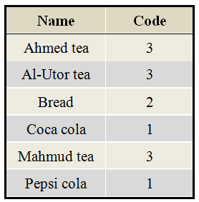

Table sorted by item code

Table sorted by item code
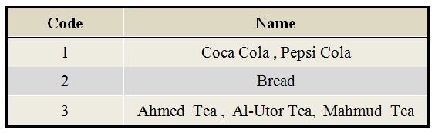
Figure 3.5 Sample of reference table’s instant

Table (3.2) sample of Reference table’s data
3.7 The Frequency-base
The Frequency-base is a database contains of k tables where k is the maximum itemset length. Each table is dedicated to specific length of itemset and contains two attributes; first the itemsets and second the itemsets’ frequency occurrence in the database(s).
Itemsets are coded from reference table and sorted according the codes, the elements (items) of each itemset is separated by comma. Sorting of itemset elements is important to make sure that there is no duplication.
Using multiple tables to store (itemset, frequency) pairs are important for achieving speed because each k^{th} table just contain k length itemset hence shorter time to access each record. A demonstration example is shown in figure 3.6.

TID | Item
2000 | AA
2000 | BB
2000 | CC
3000 | AA
3000 | CC
TID | Item
190 | AA
190 | DD
200 | BB
200 | EE
200 | FF

Transactional DB1

Transactional DB1
Transactional DB2

Transactional DB2

Item | Code
AA | 1
BB | 2
CC | 3
DD | 4
EE | 5
FF | 6
ReferenceTable

ReferenceTable

Netbot

Netbot

itemset | Frequency
1,2 | 1
1,3 | 2
1,4 | 1
2,3 | 1
2,5 | 1
2,6 | 1
5,6 | 1
Itemset_2

Itemset_2
Itemset_1

Itemset_1
itemset | Frequency
1 | 3
2 | 2
3 | 2
4 | 1
5 | 1
6 | 1

itemset | Frequency
1,2,3 | 1
2,5,6 | 1
Itemset_3

Itemset_3
Frequency-base

Frequencybase
Figure 3.6 A demo Example of frequencybase construction

Figure (3.8) Example of frequencybase construction

3.8 The Rule-finder
Rule-finder is the Third part of the proposed system. The main task of this part is to implement the queries of the users who want to find association rule. The queries may be in three forms: first querying about association rules among specified itemset to know their support count and confidence of each generated rule for this itemset, second querying for any k-itemset with the given minsup and minconf and the last one is finding strong association rules.
The proposed Rule-finder is divided into two parts: first part fetches itemset/ frequency pairs in the Frequency-base according to the minimum support the second part generates association rule for itemsets who pass minimum confidence. The second part will be time consuming because the frequencies of the items are stored in the database not in a data structure in the main memory which causes extensive I/O if there is no careful design that is suitable with database nature.
Finally before producing the output to the users, rules should be decoded to the original item name or group of items. As mentioned before ReferenceTable has capability to encode and decode items according to their name or group of items to achieve abstraction, speed and compatibility between deferent item coding for deferent databases (if differences exist).
The output could be directly sent to the screen; especially when there is a small number of rules otherwise it can be saved in a file. Figure 3.7 shows the Rule-finder’s architecture with its internal dataflow. The layers are described in the following sections.
Figure 3.7 Rule-finder Architecture

Figure (3.8) Example of frequencybase construction
Frequencybase

Fetching (itemset, frequency)
(itemset, frequency) > minsup

RuleGenerator

Decoding
Group of (itemset, frequency) pairs
1,3⇒ 2
Item1,Item3 ⇒ Item2
ReferenceTable
3.8.1 Fetch Layer
This layer is responsible for fetching data in groups according to the user’s command and organizes it in a special data structure that maps every subset to its itemset (or itemsets in the RuleGenerator). Subsets are sorted to be suitable for implementing binary search to speed up the process. Figure 3.8 shows a demo example of this data structure creations.
1,2,4
1,3,4
2,3,7
1,2,3,4,5
1,2,3, 6,7
1,2,3,4,6
0.22
0.20
0.38
Itemset
Freq.
Figure 3.8 Example of data structure creation by rule-finder

Figure (3.8) Example of frequencybase construction
This layer fetches data from Frequency-base in three different ways convenient with the manners of the user commands for association rules findings.
3.8.1.1 Finding Association Rules for Selective Group
In this method, users provide a group of items that they have interests in to find relationship between them without providing any information about minimum support or minimum confidence. This method is possible because of the nature of Data-collector that doesn’t prune itemsets according to a given threshold. The strong association rule mining is shown in algorithm 3.5
Algorithm 3.5 Finding Strong association rules algorithm

Figure (3.8) Example of frequencybase construction
SelectiveGroup(String[] items){
String ii
Foreach I in items
ii = ii + RefrenceTable.getCode (I)
k = length(items)
fre = frequency of ii in table k in the frequencybase
pass (ii,fre) to ruleGenerator with minsup =0, minconf = 0
}

3.8.1.2 Finding Association Rules in k Itemsets
In this method users will provide the program with the length (or k) of itemsets that will be interested to find association rules, minsup and minconf. This layer fetches itemsets and their frequencies, with k elements and frequency >= minsup, in the Frequency-base then sends them in groups of limited size to the next layer for generating association rules.
The idea of this method is to enable users to select the length of the itemsets that they want to produce association rule for them with a specified minsup and minconf. Algorithm 3.6 shows the pseudo code for this method.

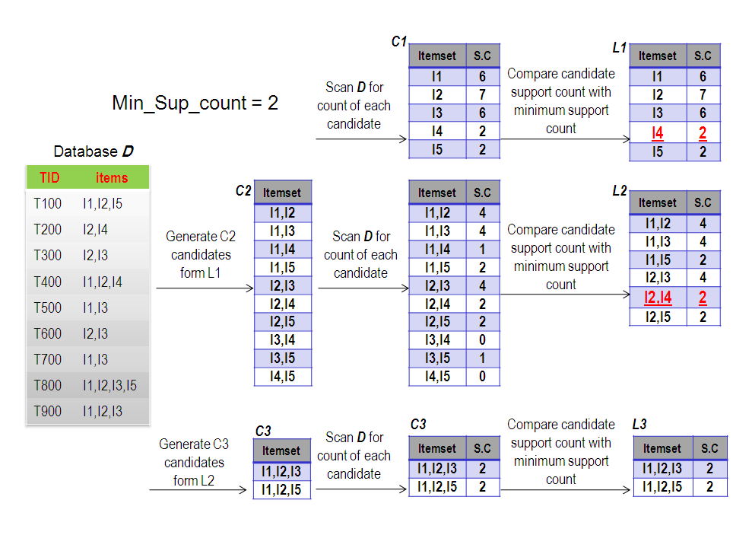
Figure 3.9 An example of Apriori strong itemset detection

Figure (3.8) Example of frequencybase construction
3.8.1.3 Simulating Apriori Algorithm Results
In this way users just provide this layer with minsup and minconf and this method will finds the largest k table in the Frequency-base with itemsets’ frequencies > minsup. This method uses previous method for passing data to the next layer after it finds suitable value for k. The pseudo code is shown in Algorithm 3.7
KitemsetAssociationRule(int k, float minsup, float minConf){
QueryResult rs
LinkedList link
TreeMap buffer
int elementNumer =0
rs = executeQuery ("Select subset,frequency from itemset_" +k+" Where frequency >= "+ minsup);
while(rs.next()){
subset = rs.getString("subset");
freq = rs.getLong("frequency");
link = new LinkedList();
link.add(new ItemSet(subset, freq));
buffer.put(subset, link);
if(elementNumer == BUFFER_SIZE){
elementNumer = 0;
ruleGenerator (buffer,k,minConf);
buffer = new TreeMap();
}
elementNumer++;
}
if(elementNumer !=0)
ruleGenerator(buffer,k,minConf)
}
Algorithm 3.6 K-Itemset Association Rule Algorithm
algorithm

Figure (3.8) Example of frequencybase construction
simulateApriory(double minSup,double minConf){
for(int k = 2; k <= NetNavigator.MAX_TRANSACTION_ITEMS; k++)
if(itemsetCount(k,minSup) > 0)
KitemsetAssociationRule (k,minSup, minConf)
else
break;

}
int itemsetCount(int k, float minSup){
int count = executeQuery("Select count(frequency) as itemCount from itemset_" + k +" Where frequency >= "+minCount)
return count
}
Algorithm 3.7 Apriori Simulation Algorithm
algorithm

Figure (3.8) Example of frequencybase construction
3.8.2 RuleGenerator Layer
The RuleGenerator generates association rules, which is the main goal of the current proposed system for itemsets coming from previous layer. This layer should use algorithms that reduce I/O between RuleGenerator and Frequency-base for this reason we choose to use a modified version of the Apriori’s simple algorithm [RAKE94] for discovering rules instead of using fast algorithm because these algorithms are made to work with (itemset, frequency) in the main memory not in a database and they are tested for speed according to the number calculations and choices they made not on the number of reaching itemsets’ frequency (support count), as it is obvious the last parameter is more important for the system because reaching itemsets’ frequency means more I/O for Frequency-base which may wastes more time than calculation. Figure 3.8 show that there is just one time that accesses frequency for subset of the itemset to find rules confidence while in the fast algorithm as shown in algorithm 3.9 there is more than one times that accesses frequency for subsets.
The modification made on the Apriori’s simple algorithm for discovering association rules is to make it possible to work with a group of itemsets simultaneously instead of individual itemset at a time. This modification will reduce I/O time by fetching groups of items and their subsets instead of using different query for each subset of itemsets. Algorithm 3.10 shows RuleGenerator’s algorithm used in the proposed System.

forall large itemsets I_{k}, k ≥ 2 do
genrules(I_{k}, I_{k});
//The genrules generates all valid rules ă ⇒ (I_{k} – ă), for all ă ⊂ a_{m}
procedure genrules(I_{k}: large k-itemset, a_{m}: large k-itemset)
A = {(m - 1)-itemsets a_{m-1} | a_{m-1} ⊂a_{m}};
forall a_{m-1}∈A do begin
conf = support(I_{k})/support(a_{m-1})
if (conf ≥ minconf) thenbegin
output the rule a_{m-1} ⇒ (I_{k} - a_{m-1}), which confidence = conf and support = support(I_{k})
if(m – 1 > 1)then
call genrules(I_{k} , a_{m-1}) ;
end
end

Algorithm 3.8 Apriori’s Simple Algorithm for rule detection

forall large k-itemsets I_{k}, k ≥ 2 do begin
H₁ = {consequents of rules divided from I_{k} with one item in the consequent};
call ap-genrules(I_{k}, H₁);
end

procedure ap-genrules(I_{k}: large k-itemset, H_{m}: set of m-item consequents)
if (k > m +1 ) then begin
H_{m+1} = apriori-gen(H_{m});
forall h_{m+1} ∈ H_{m+1} do begin
conf = support(I_{k})/support(a_{m-1})
if (conf ≥ minconf) then
output the rule a_{m-1} ⇒(I_{k}-a_{m-1}), which confidence =conf and support= support(I_{k});
else
delete hm+1 from Hm+1;
end
call ap-genrules (I_{k} , H_{m+1}) ;
end
//apriori-gen algorithm
Insert into C_{k}
Select p.item₁, p.item₂,…, p.itemk_{k-1}, q.item _{k-1}
From L_{k-1} p, L_{k-1} q
Where p.item₁ = q.item₁, …, p.item_{k-2} = q.item _{k-2}, p.item_{k-1} < q.item _{k-1}
Next, in the prune step, we delete all itemsets c ∈ C_{k} such that some (k - 1)-subset of c is not in L_{k-1}

forall itemsets c ∈ C_{k} do
forall (k - 1)-subsets s of c do
if(s ∉ L_{k-1}) then
delete c from C_{k};
Algorithm 3.9 Apriori’s Fast Algorithm for rule detection

String strItemsets;
void generateRule(TreeMap itemSet, float minConf, int k){
if(k == 0)
return;

subsets = {(m - 1)-itemsets a_{m-1} | a_{m-1} ⊂a_{m,} a_{m} ∈ itemSet };
LinkedList link = null;

QueryResult rs = executeQuery("Select subset,frequency from itemset_" + currentK + " Where subset IN ("+strItemsets+");");
while(rs.next()){
subset =rs.get ("subset");
frequency = rs.get ("frequency");
superSets = List of superset(s) of subset
foreach super ∈superSets {
conf = getSupport (super)/frequency;
if(conf >= minConf)
output the rule a_{m-1}⇒(I_{k}-a_{m-1}), which confidence =conf and support= support(I_{k});
else{
remove super from superSets;
if(count(superSets) == 0)
remove subset from subsets;
}
}
}

If(subset(subsets)>0)
generateRule(subsets,minConf, k - 1);
}

Algorithm 3.10 RuleGenerator Algorithm

